Application of Similar Triangles

Name
Institution of Affiliation
Professor
Date

Abstract
The experiment is about triangle similarity and how it can be incorporated in the determination of unknown heights that cannot be measured directly. In some cases, it is hard to know the height of some structures like buildings and other landmarks. The use of similarity makes this process easier and simpler. The procedure followed was the use of an incident angle and ray versus the reflected angle. Different measurements were recorded at various times of the day for accuracy enhancement. The results showed that the extent of size is not a limiting factor for similar triangles. The height of the tree was evaluated and determined by meeting the purpose of the experiment.

Application of Similar Triangles

Introduction
One of the most natural ways of measuring and calculating heights of different objects and elements is through the law of reflection. The items and objects involved are usually hard to measure their heights directly.Similar triangles were incorporated in the experiment, but it was important to note that triangles could possess the same characteristics and properties. However, they could not be similar following the different theorems utilized in assessing for similar triangles.The theories used in triangle similarity give specific conditions for which the triangles are identical, and the focus is on the angles and sides of the involved triangles (Markgraf, 2018).Whenever a particular sides and angles combination meets the theorems involved, the triangles were considered similar. Three theories of triangular similarity are mainly engaged in the assessment of the similarity of the triangles.Whenever there are two equal angles, then the remaining edge should be the same, rendering the triangle similar. Also, whenever the three involved sides are in equal proportions, then the triangles are considered similar. Lastly, whenever two sides are in equal proportion with the same angle of inclination, then there is a similarity of the triangles involved.
The first theorem indicates that when two triangles have two equal angles, then there is a similarity between the two triangles. This theorem is clearly illustrated in that the summation of the angles in a triangle is 180⁰. The third angle is mainly assessed by subtracting the sum of the two angles from 180 degrees.This assessment is an angle-angle side theorem or AAS. The other hypothesis is that if two triangles have equal angles with the same shape, then they are considered similar. This process isa theorem of angle angleangle or the AAA. It is vital to note that whenever two triangles are the same, the implication is that they are identical or congruent, but not similar (Khaliluzzaman et al., 2016).Similar triangles require to have two of its sides proportional to the other triangle. Forinstant, the proportion of the sides may follow a factor of five in that one side of a particular triangle is five-time the side of the similar triangle, and the other sides follow the same.There is proportionality observed in the two triangles. The last theorem, which was utilized in the experiment, was the side angle side (SAS) theorem. This approach states that two triangles are similar whenever two of its sides and angles are proportional to each other (Wang et al., 2014). The above instance could be utilized in explaining the theory of SAS concerning thestandard angle between triangles. Structures and elements that are difficult to measure their heights, the use of similar angles could be utilized in the assessment. The experiment followed the law of reflection while using the side angle side theorem in the calculation of the height of a tree.

Purpose
The experiment aimed to use similar triangles in evaluations of heights of selected trees while observing the law of reflection.

Apparatus
- Mirror
- An object that cannot be directly measured, a tree for this case
- An object that the height can be measured directly
- Measuring tape
- Pencil and notebook
- A clear line of sight between the objects involved

Procedure
- Two objects were chosen, which included a person and a tree.
- The height of the person was measured and recorded.
- A mirror was placed between the person and tree, and the person moved backward and forward until they saw the top of the tree. This measurement was taken as the height of the tree, as shown in the diagram below. For the best results, the mirror was moved several times to attain the best outcomes.
- The distance between the mirror and the person and the tree base to the mirror was measured and recorded.
- The diagram for the scenario was neatly illustrated, indicating the location of the mirror and the two involved elements. Similar triangles were then shown to represent the situation under consideration.
- The triangles were labeled with the information and data recorded, and care was taken in considering the congruent angles. This consideration was to find the corresponding sides of the triangles. The representation for this was as in the diagram illustrated below. The governing rule was that the angle of reflection is always equal to the angle of the incident.
- The height of the tree was then evaluated, utilizing the expertise in similar triangles.

Results
Various readings and measurements were carried out and recorded as in the following table for evaluation of the unknown height of the tree. For better accuracy of assessment, three readings were recorded, and their means used for the calculation of the tree’s height following the laws of triangular similarities. The estimates and the table followed the following procedure in the evaluations. For a tree shadow of 26 feet;
$$\frac{H}{D}=\frac{h}{d}$$
$$H= \frac{h*D}{d}$$
$$H= \frac{5*26}{6.5}$$
= 20 ft
The other heights followed similar steps in their evaluations to attain the height of the involved tree and were represented in the following table.

Table 1
Results obtained from the experiment.
Trial | D (ft) | d (ft) | h (ft) | H (ft)
1 | 26 | 6.5 | 5 | 20
2 | 20 | 5 | 5 | 20
3 | 30 | 7.5 | 5 | 20
Mean | 25.33 | 6.33 | 5 | 20

The set put was sketched in the following diagrams for easy evaluation and assessment of the heigh of the involved tree. Standard sides and angles were determined before completing the experiment to determine if the triangles involved were similar.

Figure 1
Experimental set up.
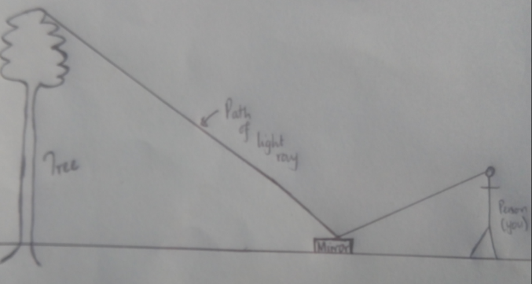
The set up followed for the above calculation was as illustrated in the following figure.

Figure 2
Calculation set up.
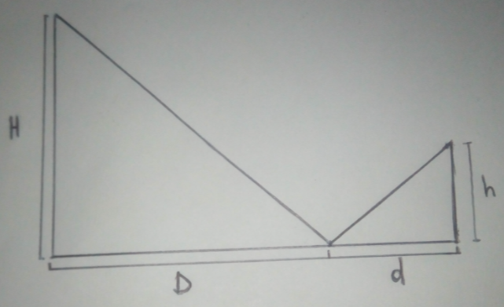

Discussion
The use of a similar triangle is essential in the determination of structure and objects that are difficult to measure using direct methods. Similar triangles share different properties as introduced above, and the extent of the side is not a limiting factor in the calculations. Following the set, as explained in the procedure, the unknown height of the tree was evaluated utilizing the values of the known object (me). On confirming the similarity of the triangle using the different theorems as discussed, the height of the tree was determined. Several measurements were taken to cater for accuracy and deviation from the mean value. Different times of the day were involved in the analysis noting various factors that may after the experiment like temperature and clarity of the shadows cast by the objects involved. The accuracy of the measuring equipment was also a factor of consideration for accurate and precise results.The triangles involved in this experiment were similar, with corresponding sides and angles determined. The similarity in triangles has been utilized for long in determinations of heights and distances, starting with the known values and measurements. It can be incorporated in most of the industries involved in manufacturing and production.
The height of the tree was evaluated using data from three different readings (different times of the day), and the value found was 20 feet. The congruent angles were determined together with the proportional sides, and various calculations followed in the evaluations. The experiment is adversely affected by the conditions of the weather involved. Measuring equipment tend to behave differently in different weather conditions. This variation is a cause of experimental errors that could be stratified and accumulated as the calculations proceed. It is essential in the future to consider the accuracy of measuring devices and conditions of the involved weather. More data is also needed to ensure the precision and accuracy of the associated information and data. The other errors were mainly expected in transferring the measured data for the record. Wrong information and data may be transferred, rendering the calculations inaccurate, which leads to inappropriate conclusions.

Conclusion
Following various configurations as indicated in the introduction, the side-angle-angle (SAA), angle-side-angle (ASA), and side-angle-angle (SAA), the size of the sides is not a limiting factor in the evaluations as the triangles are always similar.The theorems are further simplified into angle-angle AA, meaning that the three involved angles are the same, rendering the similarity in the triangles involved.However, the resemblance is not only ensured by the configurations of angle-side-side or side-side-angle. It is vital to consider care between SSA and SAS as the angles and sides indicate the order of encountering angles and sides. Human errors are inevitable in this experiment, which could have been as a result of wrong data entry or inaccuracy in measuring apparatus like the tape measure. In specific cases, for example, in right-angled triangles, whenever two involved sides are proportionate with similar angles that are not included, then there is a similarity between the angles. For the remaining cases, the triangles have been found similar or not similar accordingly. The conclusion was that similar triangles tend to fit in each other, scale from each other, and have identical parallel sides.It is vital to assess whether the triangles are similar by the theorems whenever the stated characteristics and properties are applicable in the geometric solutions.

References
Khaliluzzaman, M., Deb, K., & Jo, K.-H. (2016). Stairways detection and distance estimation approach based on three connected point and triangular similarity. 2016 9th International Conference on Human System Interactions (HSI). Portsmouth: IEEE Xplore Digital Library .
Markgraf, B. (2018, May 14 ). What are the Triangle Similarity Theorems? Retrieved from Sciencing : https://sciencing.com/what-are-the-triangle-similarity-theorems-13712278.html
Wang, S., Pan, H., Zhang, C., & Tian, Y. (2014). RGB-D image-based detection of stairs pedestrian crosswalks and traffic signs . Journal of Visual Communication and Image Representation , 263-272.

